Search

1.Complier vs interpreter vs transpiler

1.Compiler vs interpreter vs transpiler

Compiler:

Compilers are an essential part of software develop.

Compiler: A compiler translates code from a high-level programming language into machine code before the program run.

The source code is written in a high-level, That can be read easily by a human such as java or c++. A programmer writes the source code in a code editor or an (IDE) that includes an editor, saving the source code to one or more text files. A compiler that supports the source programming language reads the files, analyzes the code, and translates it into a format suitable for the target platform.

**Benefit of using compilers:**

1) Compilers is secure

2) It detects errors. Compilers can identify more types of errors and bugs.

3) It supports several programming languages. The compiler supports several high-level languages, such as C, C++, C#, Scala, and Java.

Interpreter:

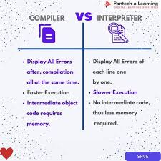

Interpreter: An interpreter translates code written in a high-level programming language into machine code line-by-line as the code runs.

**Benefit of using interpreter:**

1) It's easy to debug. Code debugging is easier with an interpreter because it reads the code line by line. It also makes it easy for programmers to debug or modify the code.

2)It's smaller. Interpreters don't generate new separate files, so they're smaller in size.

3)It's memory efficient. An interpreter has no temporary storage of the translated codes.

4)It produces a multiplatform code. Interpreters don't produce a code that's specific to a particular processor. It generates a multiplatform code, which means it can run on two or more different hardware platforms.

Transpiler:

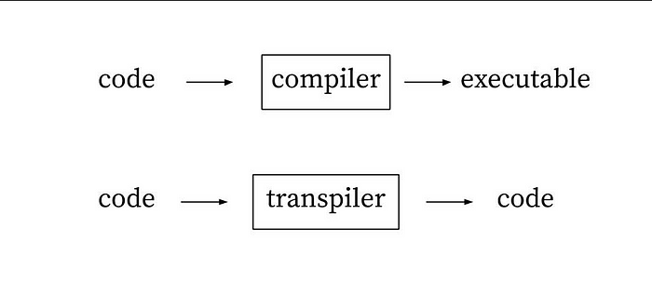

Unlike compilers, Transpilers convert code to code. Transpilers also known as source-to-source compiler because it takes source code written in one language and transform it into another language that has a similar level of abstraction.